Does Uber’s Surge Price Violates Antitrust Law?

1. Introduction

Recently, Uber CEO Travis Kalanick has been sued under antitrust law as the plaintiff argues that he and the other Uber drivers agreed on a price-fixing arrangement, which violates the Sherman Act, by using the surge price algorithm in the Uber smartphone app. This case, *Meyer v. Kalanick,* has not been decided yet by the court, while without the court’s final decision, it is interesting for economists to investigate the role of sharing economy firms, like Uber, in the context of antitrust law and competition policy. In this paper, I analyze the potential arguments from both sides of the plaintiff and the defendant in the *Meyer v. Kalanick* case. I find that Uber works as a platform for peer-to-peer service transactions to happen, thus Uber implements a vertical collusion, instead of horizontal collusion, with its drivers. Meanwhile, research evidence supports the argument that this vertical collusion creates more consumer surplus in the market compared to the situation without Uber’s existence. Finally, I conclude that Uber and its drivers should not be considered in a violation of the Sherman Act. I organize the paper into five sections: Section II introduces the background of emerging sharing economy and Uber. Section III analyzes the arguments from the plaintiff and the defendant, respectively. Section IV displays my economic analysis on Uber’s antitrust concerns. And Section V concludes the paper.

1. Background

Before further investigate whether Uber is involved in a violation of antitrust law, it is better for people to get familiar with what is sharing economy, the category which many emerging innovative firms such as Uber, Airbnb, etc. belong into, because it is the property of sharing economy makes these firms different from the traditional industries and promotes the growth of the gig economy[1]. The sharing economy refers to the emergence of peer-to-peer services that allow owners to give strangers access to their property during the time the owner does not wish to use it. Peer-to-peer markets allow small suppliers to compete with traditional providers of the same good or service, making it easy for buyers to engage in convenient, trustworthy transactions. (Einav, Farronato, &Levin 2015) These services are typically in the form of mobile apps and webpages which allow much easier access for customers compared to the traditional businesses. As a result, the traditional businesses are losing consumers to these services as they provide a more effective and less cost substitute. On the side of service providers, firms like Uber and Airbnb give people who have full-time jobs the chance to rent out their own properties which are not be using, sometimes even their spare time, to earn extra income. For example, Airbnb allows house hosts to rent their homes to strangers with a price usually much lower than hotels, making the usage of the property more efficient for both house owners and travelers. Uber allows the vehicle owners to do the same thing, and additionally, drivers also provide their service of driving combined with the availability of vehicles to passengers.

With the knowledge of sharing economy, it is time to explore how Uber’s business model works and why its surge price mechanism was sued for violation of the antitrust law. Uber began in 2008 as an idea to create an app to get a ride when a person had trouble hailing a taxi.[2] From the consumer perspective, Uber is an app that connects them with available drivers in the area. The app allows the rider to view the estimated arrival time of their ride, car description, and the likely fare using the Uber Fare Estimator.[3] From the driver perspective, things are more complicated. Drivers are required to fulfill a list of conditions, from age, driving experiences to a background check. And if during the ride, drivers’ behaviors violate Uber’s policy and/or are complained by customers, investigations are triggered to demonstrate whether the drivers were behaving properly. This design ensures that Uber’s services are provided with a satisfying level of quality, at the same time linking as many as possible drivers to passengers.

The key part of the service that led to the suit of antitrust law in Uber’s surge price mechanism, an algorithm Uber uses to calculate the fare rate should passengers pay to the drivers. Uber collects the data of how many app users are looking for a ride in a given geographic area at the same time and increases the price of the service to attract more drivers to kick in when the local demand rises. As a result, when during periods like rush hours, a big volume of consumers simultaneously start seeking for a ride, the Uber fare could increase significantly, ranged from 1.2 times of regular price to even more than 10 times. For example, the figure below displays a typical billing with surge price at 1.4x fare rate.

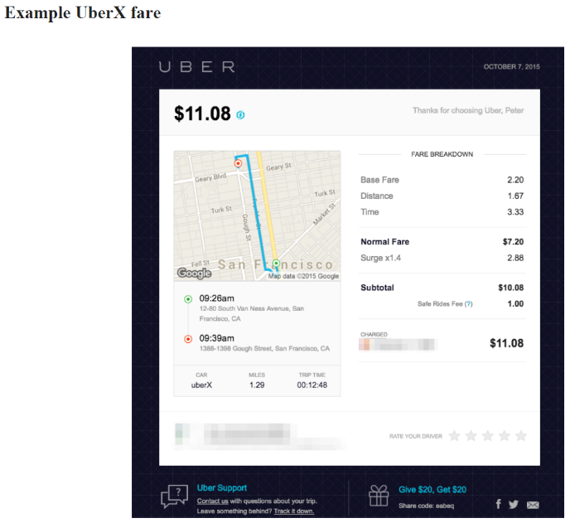Resource: Cohen, Peter, et al. *Using big data to estimate consumer surplus: The case of uber*. No. w22627. National Bureau of Economic Research, 2016.

1. Arguments from the plaintiff and Uber

The plaintiff’s complaint against Uber states that the company’s business model amounts to a conspiracy to fix prices and exploits a huge part of profits generated from the practice of this anti-competition activity. On the other hand, the company claims that there is no price-fixing because drivers are actually free to offer a price lower than the one displayed on the Uber app. But this argument was rejected by the Judge Jed Rakoff who supervises the case because the app does not provide any mechanism to do so. Drivers could only give back cash to customers since customers are paying the fare inside the app via cards automatically after the ride, and it is impossible to announce such a discount to customers before a ride is ordered.

One critical fact of Uber’s surge-pricing is that all drivers active in the locations where price are increased due to high demand are called for the same price by Uber’s app, and this becomes the necessary part of the allegation that the drivers are engaging in a price-fixing conspiracy. One may claim that Uber as a single firm definitely has the right to charge a uniform price for the service it provides, and there is no sense to raise an antitrust investigation on such a normal business behavior. However, in the previous lawsuit[4], Uber has claimed several times that all drivers are not their employee but independent actors who work as driver-partners and accepts the contractual terms which include the use of surge price algorithm. The reason Uber argued this is the result of the previous lawsuits involving workers’ right. When Uber drivers in the past have sued Uber to provide minimum wage, health benefits, mandatory overtime, and other rights that the government requires employers to provide to its workers, Uber has been able to successfully defend itself on the grounds that the drivers are not employees. Therefore, Uber is vulnerable to the antitrust concern of a conspiracy with drivers on a price-fixing collusion because it claims to be a contractor instead of an employer to its drivers. The lawsuit appears to be one in which the plaintiff alleges a horizontal price-fixing conspiracy among Uber drivers, while I will explain why this may not be the case in the following sections.

According to the Sherman Act, horizontal collusion cases are straightforward: it is prohibited regardless of its real-world effect. Once it is determined that firms are implementing the horizontal collusion, firms are required to stop the illegal activities and pay penalties on the parties to the conspiracy. By contrast, the cases of vertical price-fixing are more ambiguous. Due to the existence of double marginalization in many industries, it is sometimes beneficial to consumer surplus. For instance, a downstream company wants to set up a price as high as possible to maximize its benefits, while an upstream manufacturer wants a high enough volume to ensure its profitability. To handle the contrary between high retail price and high sales, two firms may setup a contract fixing the price to a level that both firms gain more profits. In most cases, such vertical price-fixing could result in a lower retail price and consumer surplus increases. Thus, under such circumstances, it is legal for a supplier to contract with buyers to set transactions between them at a fixed price.

Therefore, the question of whether Uber works as a two-sided platform becomes important because it defines Uber’s role in the market for car ride services. A two-sided platform is a firm which stands in the middle between customers and producers and provides each group with the network benefits from direct interactions. This seems like what Uber is doing: customers and drivers are arranged to each other by Uber on its app platform, and Uber is paid by the customers and then transfers part of the payment to drivers. Briefly, Uber is buying services from the driver and then selling them to customers. In this case, the market is in a vertical structure, and from the antitrust perspective, Uber sets thousands of vertical agreements to its drivers to set up a fixed price for all drivers and surge pricing along the demand.

Passaro (2016) provides another reasoning that why Uber implements vertical price-fixing agreements instead of horizontal one. For a horizontal collusion agreement to exist, Uber needs to negotiate with all his drivers and convince them that other drivers will not charge a different price. However, this is not possible for Uber to finish this task by simply making drivers sign the contract which mentions the use of surge price algorithm. Neither Uber can implement the enforcement of charging uniform price among all driver, nor drivers will hold the belief that each other driver is certainly charging the same price shown on the app. Drivers’ purpose of joining Uber is not that Uber promises a fixed price which increases the profits of providing ride services by horizontal collusion, but it is the network benefits offered by the platform of Uber app that gives drivers incentives to start the business. This reasoning demonstrates that the contract between Uber and drivers does not tend to provide an implicit horizontal price-fixing agreement, and differently, Uber is more prone to an allegation of vertical collusion which is not necessarily illegal depending on the real-world effect it brings. In the next section, I further analyze the effects of Uber’s surge price are likely to be positive.

1. Economic Analysis

In this section, I survey several literature on Uber’s surge price mechanism in the following order: first, I display the efficiency of Uber’s surge price algorithm; second; I analyze its effect on supply side of the on-demand drive market and finish the section with the analysis of its effect on demand and consumer surplus.

1. Efficiency of Uber’s Surge Price

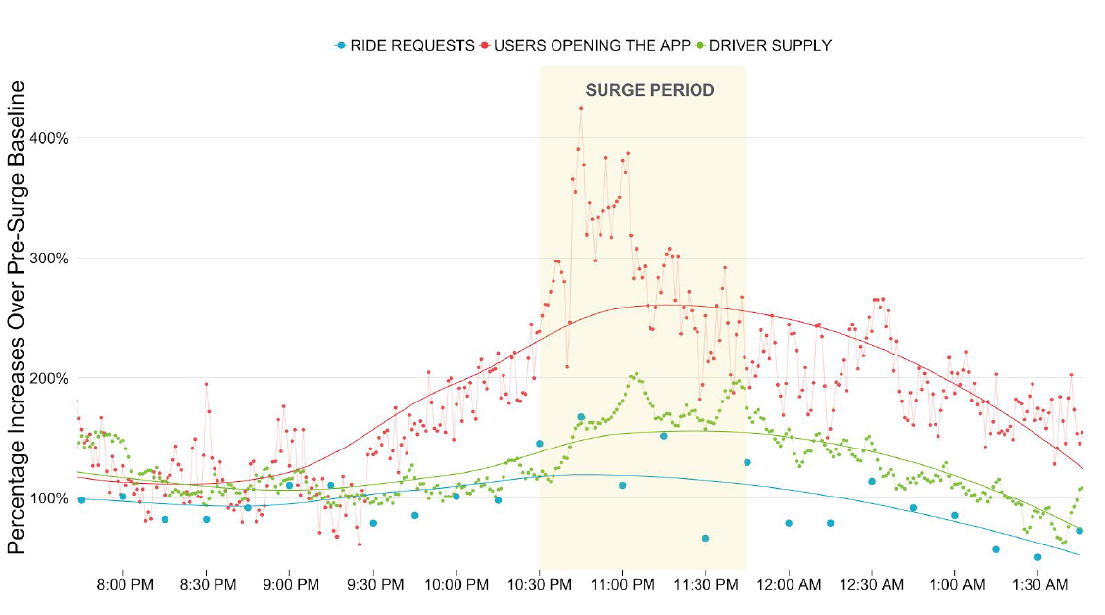Uber’s surge price mechanism is designed to equilibrate supply and demand. The surge multiplier is presented on the app when demand in the location increases, and the rider must accept the higher price to book a ride. This applies the simple economics theory of demand, that is when demand increases, the equilibrium price should also increase. In the traditional taxi industry, since the fare is fixed in most of the times, it lacks the mechanism to adjust the price when demand fluctuates and a shortage of supply occurs. As a result, it is hard to hail a taxi in a rainy day. While with surge pricing, Uber has more active drivers to fill the gap between demand and supply during a rush hour by increasing the price. Therefore, people who need a ride can have the service they want without much waiting and people who have other cheaper outside options or fewer opportunity costs can choose other transportation or just wait for the surge falls back to regular level. Economic theory tells that this improves the efficiency of the market and brings more benefits to both drivers and riders (all riders in total).

Resource: Hall, Jonathan, Cory Kendrick, and Chris Nosko. "The effects of Uber’s surge pricing: A case study." *The University of Chicago Booth School of Business* (2015).

To test whether the design of surge pricing works in real-world context, Hall, Kendrick & Nosko (2015) collects data on users’ activities on the Uber app and uses two samples to illustrate how the market acts with and without surge pricing market. The figure displayed on the previous page shows the demand and supply of rides at Madison Square Garden, New York on March 21, 2015, when a pop superstar’s concert ended and the large volume of people caused a large spike in demand. As the event ended by 10:30 pm, the number of users opening the app increased tremendously and triggered the surge period. As a response to the high price, drivers supply also increased during the surge period which is predicted by the theory. Researchers mention that even in the face of a large increase in demand, the completion rate, defined as the percentage of requested rides that end in a completed trip, did not change and customer’s waiting time only increase by one minute on average. These results prove the efficiency of the surge price mechanism. An interesting fact is that volume of ride requests did not obviously increase during the surge period. A possible reason is that customers opened the app and viewed the high surge price, so they decided to wait until the surge period passed.

Another example Hall, Kendrick & Nosko (2015) offers is a natural experiment caused by a surge outage due to technical issues during a period of peak demand. During the New Year’s Eve 2014-2015, the surge pricing algorithm across the New York City broke down for 26 minutes. At the same time, the demand is unusually high and the excessive part was not adjusted by the surge pricing. As a result, completion rate fell dramatically during the period as lack of available active vehicles largely increased the waiting time. “Without the surge pricing to equilibrate demand and supply, driver supply failed to satisfy rider demand with low wait times.” (Hall, Kendrick & Nosko 2015)

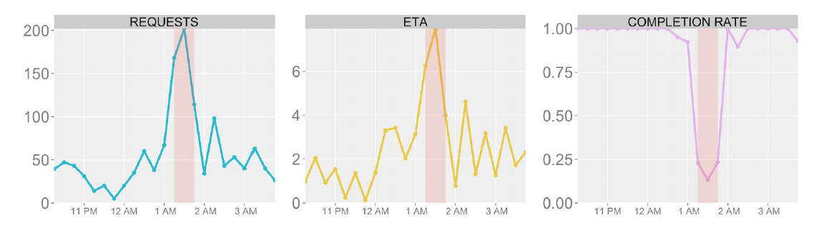

Resource: Hall, Jonathan, Cory Kendrick, and Chris Nosko. "The effects of Uber’s surge pricing: A case study." *The University of Chicago Booth School of Business* (2015).

From the previous two examples, researchers show that how surge pricing works efficiently to fulfill the increasing rider demand with extra driver supply attracted by the higher payoff. There are big efficiency gains generated from both an increase in the supply of drivers and from an allocation of supply to those that valued rides the most. This result casts doubt on the argument that Uber’s surge price mechanism is a practice of vertical collusion which deteriorates consumer’s surplus as the plaintiff of the *Meyer v. Kalanick* case claims.

1. Surge Pricing’s Effect on Supply Market

Much previous literature has done comprehensive research on the behaviors of workers when they can flexibly choose how long to work each day. In a study of taxi drivers, Camerer et al. (1997) claim that drivers tend to quit when they achieve a daily income target and drive less when hourly earnings are high. If this phenomenon is true among Uber drivers, then its vertical fix-pricing collusion with drivers is likely to harm consumers’ surplus, because drivers could quit when surge price is high and less service are provided.

However, Chen and Sheldon (2015) find different patterns in Uber drivers’ behavior at high surge times. In contrast to the income-targeting literature, they find that “in response to surge pricing, Uber driver-partners choose to extend their sessions and provide significantly more rides on the Uber platform.” Besides, they also find large positive supply elasticities, suggesting that surge pricing increases the efficiency of the market. The explanation for their surprising findings may rely on the property of Uber’s earnings-per-trip. Unlike taxi driver whose income is influenced by trip frequency in the area, Uber drivers could have extremely higher earnings from one single trip during the high surge period than regular time. As they have access to current prices and information like estimated earnings, work time and trips, Uber divers could organize their time more efficiently and need not rely on a daily income target. Overall, Chen and Sheldon (2015) conclude that the idea of surge pricing significantly increases the efficiency of on-demand service markets and supply of rides by incentivizing driver-partners to provide more rides than they would have absent surge prices.

1. Effect of Surge Pricing on Consumer Surplus

As antitrust laws focus on the benefits of consumers, it is important to know the effect of Uber’s surge price mechanism on consumer surplus to justify its implicit vertical collusion activities. While it is always challenging to estimate an accurate consumer surplus, with the abundant individual-level data collected from Uber users, Cohen et al. (2016) uses the discontinuity at the threshold between discrete surge rate levels to estimate demand elasticities and then estimate the consumer surplus. Their results strengthen the implication that Uber’s surge price is beneficial to the consumers.

To understand their method of calculating consumer surplus, people should first know how does Uber come up with the surge price on its app. Surge price reflects local demand and supply conditions and is calculated to an arbitrary number of decimal places. For simple and easy user experience, Uber presents surge price with discrete price increments on the app, which creates the discontinuity at the approximation threshold between two displayed numbers. For example, market conditions are nearly the same for a surge of 1.249x and 1.251x, but consumers should face 1.2x in one case and 1.3x in the other case. Such natural discontinuity provides the opportunity for researches to estimate local elasticities of demand across the surge prices. After controlling other factors, the ratio of an increase in surge price can cause how much decrease in the request for rides is the elasticity at that point.

With the estimates of demand elasticities, researchers transform these estimates into an overall measure of consumer surplus. To estimate consumer surplus, people need to identify at which price are the consumers indifferent to buy the service, which is contrafactual and unobservable. To solve this problem, Cohen et al. (2016) use propensity score methods to identify a group of observations that saw high surge prices, but their observable factors match the other group who did not see surge price. In this way, the difference between the willingness to pa and the price the consumers pay, which sum up to the consumer surplus, is calculated. The final estimates of consumer surplus are approximately 1.57 times as large as consumer payment on rides, which more than six times Uber’s revenues generated from the samples.

1. Conclusion

The antitrust lawsuit against Uber focuses on its surge pricing: Uber’s algorithm is charging consumers more than they would pay for traditional taxis services in times of peak demand. This paper discusses the elasticity of driver supply and rider demand when there's a surge. Studies indicate that consumers may be paying more, but they are getting their rides more quickly and efficiently than they would from a fixed supply of traditional taxis or the situation without surge pricing. Moreover, there is research providing a justification for Uber that it allocates a scarce good—car rides, especially in periods when it is hard for people to get them, to the consumers who value them most. Surge pricing solves the problem of excess demand when many people seeking for the one available taxi in a rainstorm by increasing the payment for such a service. Thus, the person who most values staying dry (or who is simply the richest) gets the cab. In this way, using price increases to allocate scarce goods not only benefits the company, but also the consumers, and resulting in improved consumer welfare which makes the justification for the vertical collusion under the Sherman Act.

**Reference**

Camerer, Colin, et al. "Labor supply of New York City cabdrivers: One day at a time." *The Quarterly Journal of Economics* 112.2 (1997): 407-441.

Chen, M. Keith, and Michael Sheldon. *Dynamic pricing in a labor market: Surge pricing and flexible work on the Uber platform*. Mimeo, UCLA, 2015.

Cohen, Peter, et al. *Using big data to estimate consumer surplus: The case of uber*. No. w22627. National Bureau of Economic Research, 2016.

Einav, Liran, Chiara Farronato, and Jonathan Levin. "Peer-to-peer markets." *Annual Review of Economics* 8 (2016): 615-635.

Hall, Jonathan, Cory Kendrick, and Chris Nosko. "The effects of Uber’s surge pricing: A case study." *The University of Chicago Booth School of Business* (2015).

Passaro, Nicholas. "How Meyer v. Kalanick Could Determine How Uber and the Sharing Economy Fit into Antitrust Doctrine." (2016).

1. A labor market characterized by the prevalence of short-term contracts or freelance work as opposed to permanent jobs.
2. Uber, “Our Story,” https://www.uber.com/our-story/.
3. Uber, “How does Uber work?”, https://help.uber.com/h/738d1ff7-5fe0-4383-b34c-4a2480efd71e.
4. Scheiber, Mike Isaac and Noam. "Uber Settles Cases with Concessions, but Drivers Stay Freelancers." *The New York Times*, 21 Apr. 2016. Web.